TCPDump - capture your first packet

# Scenario

You’re a network analyst who needs to use tcpdump to capture and analyze live network traffic from a Linux virtual machine.

The lab starts with your analyst user account, already logged in to a Linux terminal.

Your Linux user's home directory contains a sample packet capture file that you will use at the end of the lab to answer a few questions about the network traffic that it contains.

Here’s how you’ll do this: First, you’ll identify network interfaces to capture packet data. Second, you’ll use tcpdump to filter live network traffic. Third, you’ll capture network traffic using tcpdump. Finally, you’ll filter the captured packet data.

# Task 1 - Identify Network Interfaces

In this task, I’ve identified the network interfaces that can be used to capture network packet data.

1. Use ifconfig to identify the available interfaces:

Command: sudo ifconfig

Output: 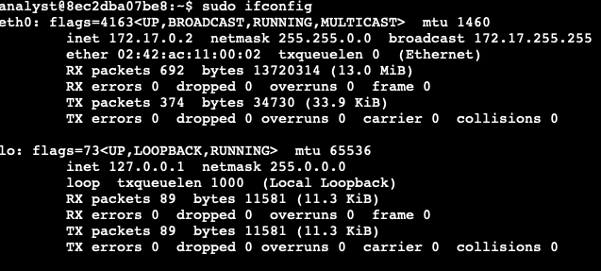

The entry identifies the Ethernet network interface with the eth prefix.

So, in this lab, I'll use eth0 as the interface that you will capture network packet data from in the following tasks.

1. Use tcpdump to identify the interface options available for packet capture:

Command: sudo tcpdump -D

Output: 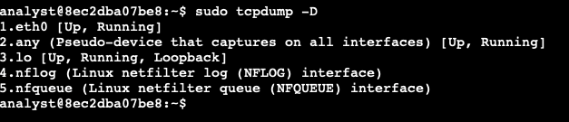

This command will also allow you to identify which network interfaces are available. This may be useful on systems that do not include the ifconfig command.

# Task 2 - Inspect the network traffic of a network interface with tcpdump

In this task, I’ll use tcpdump to filter live network packet traffic on an interface.

* Filter live network packet data from the eth0 interface with tcpdump:

Command: sudo tcpdump -i eth0 -v -c5

This command will run tcpdump with the following options:

* -i eth0: Capture data specifically from the eth0 interface.
* -v: Display detailed packet data.
* -c5: Capture 5 packets of data.

Now, let's take a detailed look at the packet information that this command has returned.

Output: 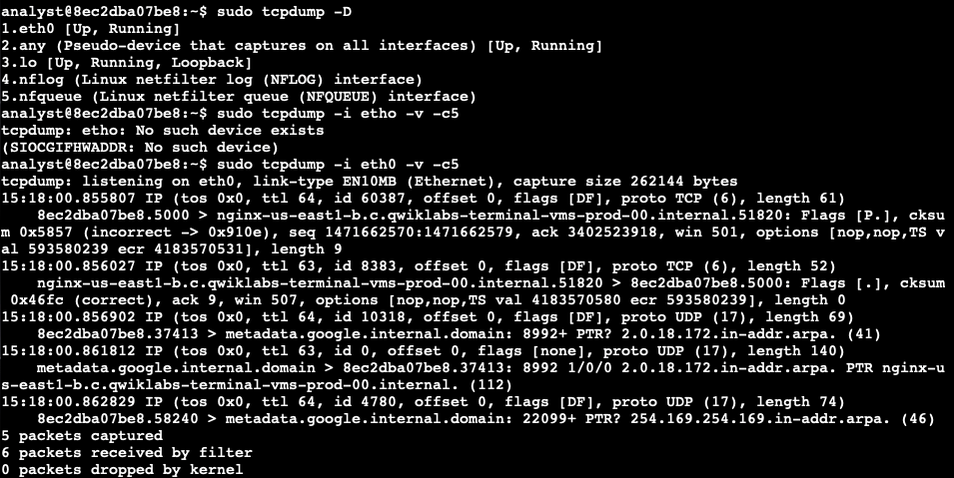

## Exploring network packet details

you’ll identify some of the properties that tcpdump outputs for the packet capture data you’ve just seen.

1. In the example data at the start of the packet output, tcpdump reported that it was listening on the eth0 interface, and it provided information on the link type and the capture size in bytes.
2. On the next line, the first field is the packet's timestamp, followed by the protocol type, IP.
3. The verbose option, -v, has provided more details about the IP packet fields, such as TOS, TTL, offset, flags, internal protocol type (in this case, TCP (6)), and the length of the outer IP packet in bytes.
4. In the next section, the data shows the systems that are communicating with each other. By default, tcpdump will convert IP addresses into names, as in the screenshot. The name of your Linux virtual machine also included in the command prompt, appears here as the source for one packet and the destination for the second packet. In your live data, the name will be a different set of letters and numbers. The direction of the arrow (>) indicates the direction of the traffic flow in this packet. Each system name includes a suffix with the port number (.5000 in the screenshot), which is used by the source and the destination systems for this packet.
5. The remaining data filters the header data for the inner TCP packet. The flags field identifies TCP flags. In this case, the P represents the push flag and the period indicates it's an ACK flag. This means the packet is pushing out data. The next field is the TCP checksum value, which is used for detecting errors in the data. This section also includes the sequence and acknowledgment numbers, the window size, and the length of the inner TCP packet in bytes.

# Task 3 - Capture the network traffic using tcpdump

I’ll use tcpdump to save the captured network data to a packet capture file.

In the previous command, I used tcpdump to stream all network traffic. Here, I will use a filter and other tcpdump configuration options to save a small sample that contains only web (TCP port 80) network packet data.

1. Capture packet data into a file called capture.pcap

Command: sudo tcpdump -i eth0 -nn -c9 port 80 -w capture.pcap &

Output:

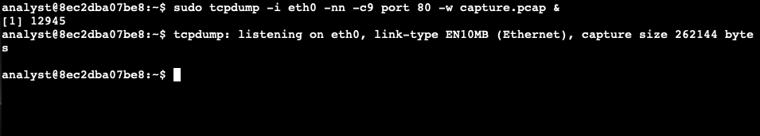

You must press the **ENTER** key to get your command prompt back after running this command.

This command will run tcpdump in the background with the following options:

* -i eth0: Capture data from the eth0 interface.
* -nn: Do not attempt to resolve IP addresses or ports to names.This is best practice from a security perspective, as the lookup data may not be valid. It also prevents malicious actors from being alerted to an investigation.
* -c9: Capture 9 packets of data and then exit.
* port 80: Filter only port 80 traffic. This is the default HTTP port.
* -w capture.pcap: Save the captured data to the named file.
* &: This is an instruction to the Bash shell to run the command in the background.

This command runs in the background, but some output text will appear in your terminal. The text will not affect the commands when you follow the steps for the rest of the lab.

1. Use curl to generate some HTTP (port 80) traffic

Command: curl opensource.google.com

Output: 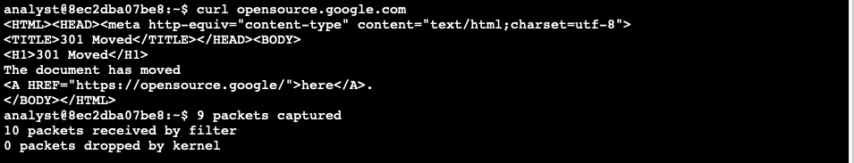

When the curl command is used like this to open a website, it generates some HTTP (TCP port 80) traffic that can be captured.

1. Verify that packet data has been captured.

Command: ls -l capture.pcap

Output: 

# Task 4 - Filter the captured packet data

Here, we’ll use tcpdump to filter data from the packet capture file you saved previously.

1. Use the tcpdump command to filter the packet header data from the capture.pcap capture file

Command: sudo tcpdump -nn -r capture.pcap -v

This command will run tcpdump with the following options:

* -nn: Disable port and protocol name lookup.
* -r: Read capture data from the named file.
* -v: Display detailed packet data.

You must specify the -nn switch again here, as you want to make sure tcpdump does not perform name lookups of either IP addresses or ports, since this can alert threat actors.

Output: 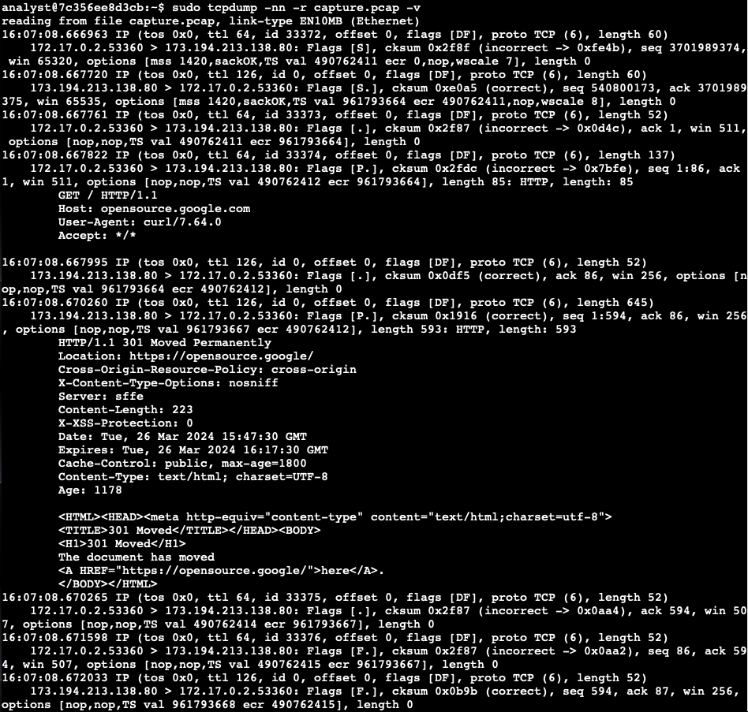

As in the previous example, you can see the IP packet information along with information about the data that the packet contains.

1. Use the tcpdump command to filter the extended packet data from the capture.pcap capture file.

Command: sudo tcpdump -nn -r capture.pcap -X

This command will run tcpdump with the following options:

* -nn: Disable port and protocol name lookup.
* -r: Read capture data from the named file.
* -X: Display the hexadecimal and ASCII output format packet data. Security analysts can analyze hexadecimal and ASCII output to detect patterns or anomalies during malware analysis or forensic analysis.

Output:

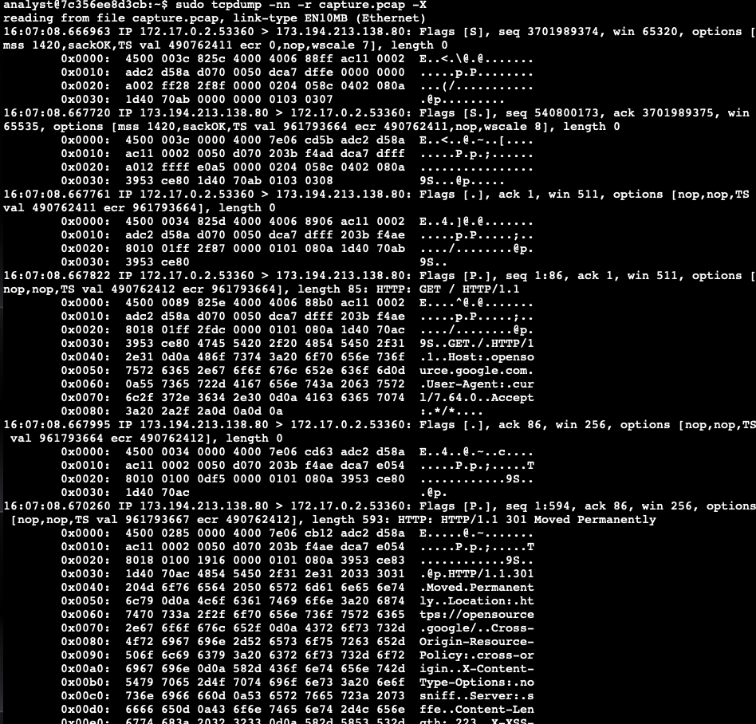

# Conclusion

Gained practical experience in:

* identify network interfaces,
* use the tcpdump command to capture network data for inspection,
* interpret the information that tcpdump outputs regarding a packet, and
* save and load packet data for later analysis.